Assignment -4

Docker and Kubernetes

|  |  |
| --- | --- |
| Assignment Date | 21 November 2022 |
| Student Name | Ragul Kumar S |
| Student Roll Number | 721719104068 |
| Maximum Marks | 2 Marks |

1.Pull an image from docker hub and run it in docker Playground 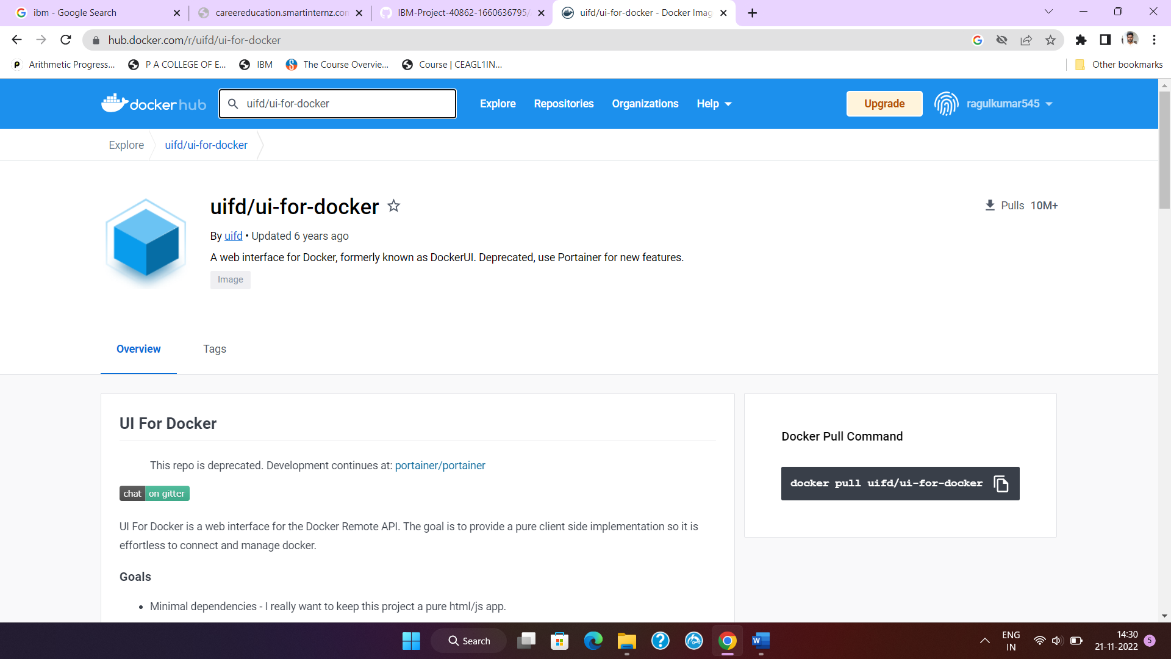

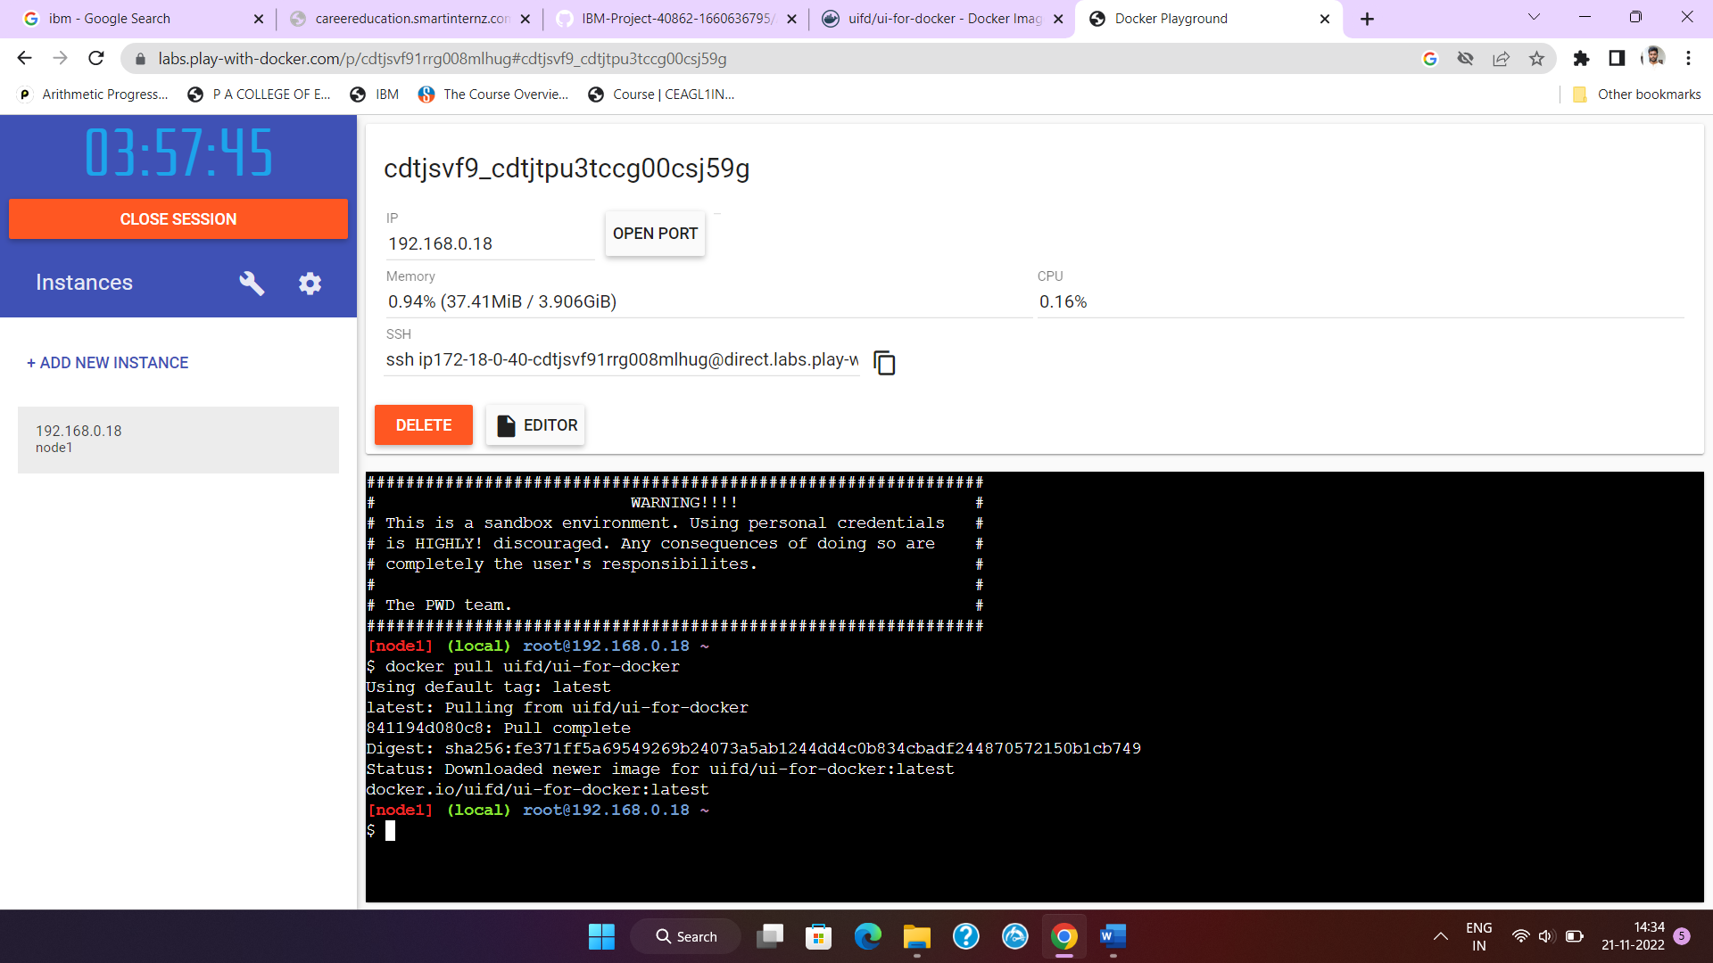2.Create a docker file for the job portal application and deploy it in Docker desktop application 